M. Brownell Anderson Award from the AAMC Western Group on Educational Affairs

We are delighted to announce the 2023 Brownie Award recipients from the AAMC Western Group on Educational Affairs, Dr. Candace Pau.
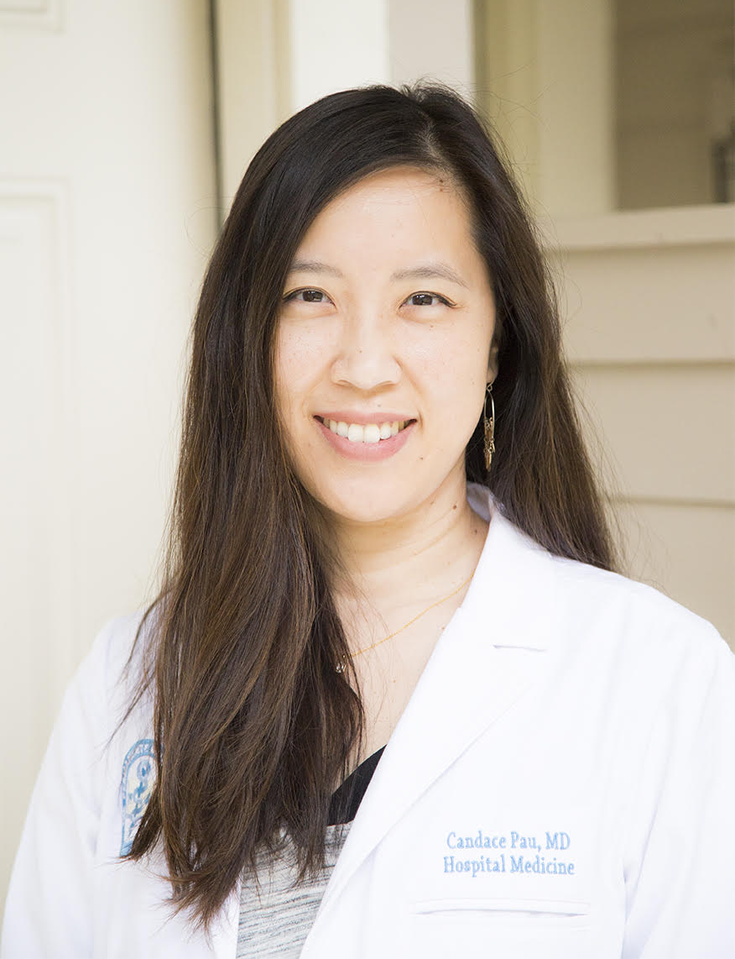

Dr. Pau is a Board-certified Family Medicine physician with experience practicing in Emergency Medicine/Urgent Care and Hospital-based Medicine settings. As the founding Faculty Director of Simulation at the Kaiser Permanente Bernard J. Tyson School of Medicine, Dr. Pau is responsible for the development and implementation of a robust, innovative simulation-based curriculum, encompassing simulation activities for both instruction and assessment at the undergraduate medical education level.
She has extensive direct teaching and curricular design experience, including the use of flipped classroom, experiential learning, and serious gaming/gamification methodologies. Her academic interests include operationalization of competency-based medical education, the use of simulation-based assessment to determine developmental trajectories of clinical skills, and the use of longitudinal case-based simulation for transition to residency.
Dr. Pau received her medical degree from Stanford University School of Medicine and completed her residency training at the Kaiser Permanente Napa-Solano Family Medicine Residency Program.

